**CS Associates Consulting Firm: A Comprehensive survey towards enhancing Customer Retention through Banking Customer Service**

Executive Summary

The CS Associate Survey gathered responses from 262 participants aged 18 and older, aiming to understand the factors influencing their decisions to discontinue banking services. These reasons encompassed issues ranging from bad processes to security concerns.

The survey results unveiled a mix of expected and unexpected findings. For instance, it was foreseeable that frequent cash withdrawals at ATMs ranked as the least possible reason, with 72% of respondents unconsidered discontinuing banking services for this reason. Conversely, one less-expected revelation was that security concerns were ranked as less possible by approximately 34% of the respondents.

Top of Form

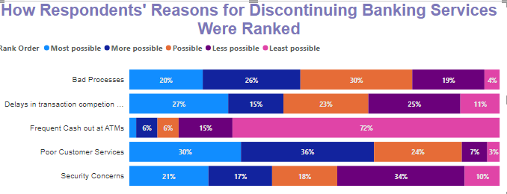

In our survey, a significant majority of respondents, 34%, preferred addressing inquiries and complaints by visiting bank branches, indicating a strong inclination toward in-person interaction. A relatively smaller portion of respondents, 3%, opted for virtual assistant/chatbot services as a means of issue resolution.

Additionally, a segment of respondents, 5%, encountered downtime while using digital banking platforms. Among those experiencing downtime, some expressed concerns about the efficiency of banking processes and indicated a potential willingness to explore alternative banking options.

This executive summary encapsulates key findings from the Customer Service Associate Survey, providing insights into the factors influencing banking service decisions, preferences in inquiry resolution, and the presence of downtime-related concerns, with relevant percentages where applicable.

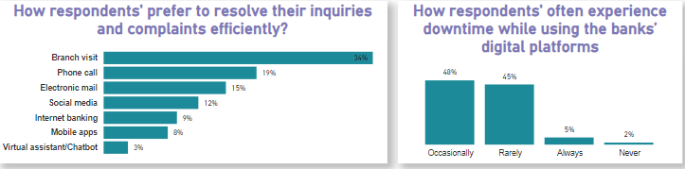

What makes these findings valuable is that they offer insights applicable to all banks. Further details and analysis of these results can be found in the 'Survey Findings' section that follows.

Introduction

Customer retention is a key metric for success in the banking sector. While acquiring new customers is essential, retaining existing ones is also important, if not more essential. A critical factor influencing customer retention is the quality of customer service provided by the bank. To assess this, CS Associate consulting firm undertook a customer service survey to understand customers' experiences and expectations better.

Survey Findings

Among the 262 respondents in the survey, a clear majority, representing 58% of the total, identified as males, while 42% were females. The age distribution of respondents unveiled intriguing trends. Notably, individuals aged between 25 and 40 years old exhibited the highest response rate, indicating active engagement with the bank's services. Additionally, a significant majority of these respondents (34%) are employed in the private sector, and the majority (34%) maintain an average account balance of ₦300,000.

Conversely, the age group of 57 and above contributed the least responses, signaling reduced engagement among older individuals. It's worth mentioning that respondents aged 41-56 maintain substantial account balances, with 10% reporting balances exceeding ₦50 million and 41% having an average balance of ₦3 million in their accounts.

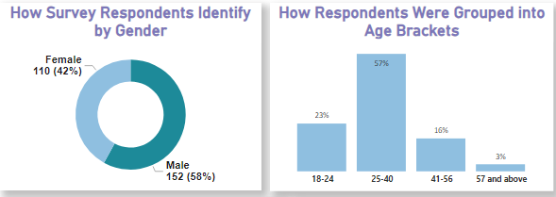 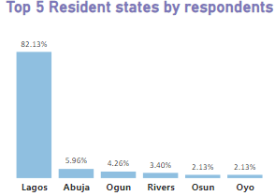

These findings highlight the importance of tailoring banking services and engagement strategies for different demographic segment as It's evident that more attention should be focused on respondents aged 25-40, younger demographic aged 18-24 and the quite older demographic, aged 41-56, to meet their unique needs and preferences effectively.

Furthermore, the survey identified Lagos State as the location with the highest percentage of residents 74% among respondents. This regional insight underscores the significance of Lagos as a key market for the bank, emphasizing the need for targeted efforts and services in this area to accommodate the high concentration of residents.

Students constituted the second-largest category among respondents, accounting for 11% of the total employment category. Notably, a significant 71% of these student respondents fell within the 18-24 age bracket. Furthermore, it's noteworthy that the majority of these student respondents reported account balances of not more than ₦1 million, with 61% indicating balances below ₦50 thousand. Digital Services

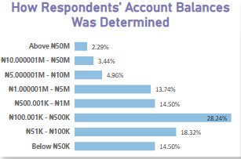 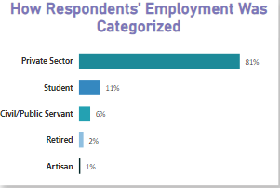

The combination of customers who "occasionally experience downtime" 48% and those who "rarely experience downtime" 45% are relatively minor and do not significantly disrupt the overall customer experience but should be cautiously assessed so as not to results in critical disruptions or security breaches, in this case, the majority of customers (48% + 45% = 93%) are not experiencing frequent or severe issues, which could indicate overall satisfaction with the bank's services.

Problem Resolution

The survey revealed that respondents primarily prefer to resolve their inquiries and complaints efficiently through in-person branch visits, with 34% of respondents choosing this method followed by phone calls with 19%. Interestingly, a substantial 72% of these respondents who prefer branch visits reside in Lagos State.

Recommendations for Enhanced Customer Retention

Given the lower engagement of older individuals, consider initiatives to make banking services more accessible and appealing to this segment. Offering specialized services and simplified digital tools can be beneficial.

Establish feedback mechanisms to actively listen to customer concerns and suggestions. Use this feedback to drive continuous improvement in services and address issues prompt.

Given the preference for branch visits, evaluate opportunities for expanding the physical branch network, particularly in areas with a high concentration of customers, such as Lagos State.

Recognize the financial diversity among customers. Develop tailored financial products and investment opportunities that match the varying account balances and financial goals of different segments.

Consider loyalty programs, rewards, and incentives targeted at retaining customers, particularly in the competitive banking landscape. Encourage long-term relationships through exclusive offers.

Conclusion

The survey findings have provided valuable insights into our customer base, highlighting the diversity of demographics, engagement patterns, and financial profiles. These insights serve as a foundation for informed decision-making, enabling us to tailor our services effectively, enhance customer satisfaction, and strengthen our retention strategies.